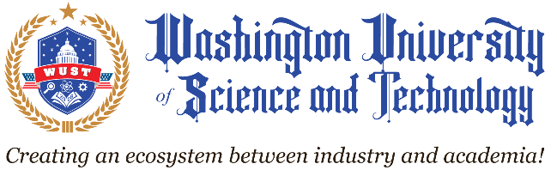

**Office of The President**

8133 Leesburg Pike

Vienna, VA 22182

Tel: 703-941-2020

Fax:703-941-2025

info@igu.edu

www.igu.edu

**May 1, 2022**

**PRESS RELEASE**

**FOR IMMEDIATE RELEASE**

**IGU IS NOW WUST**

VIENNA, VA (Metropolitan Washington, D.C.) – IGlobal University, a career college certified to operate in the State of Virginia by the State Council of Higher Education for Virginia (SCHEV) and accredited by the Accrediting Commission of Career Schools and Colleges, today announces it’s official name change to **Washington University of Science and Technology (WUST).** Along with the name change comes a new university logo.

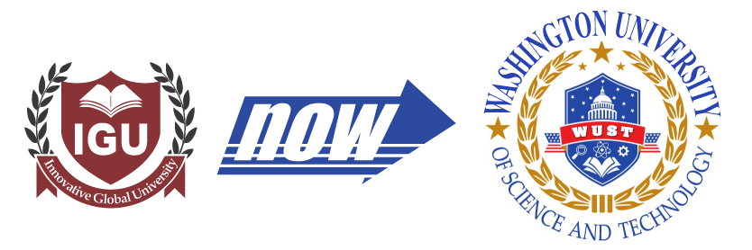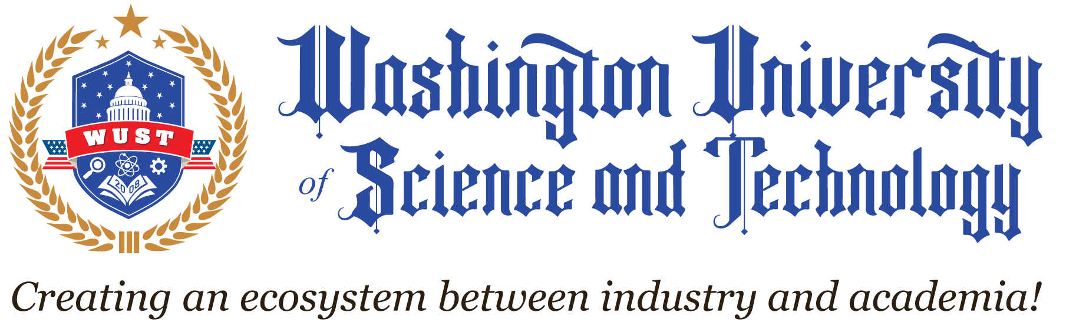

According to the President, Dr. Hasan K. Burk, “the founding mission, vision, and purpose of the university remains the same as we continue to focus on offering the best quality yet affordable career education to students from around the world. Taking the tradition from IGU, WUST will continue to create viable ecosystems between academia and industry to build a skilled workforce. Our modus operandi remains “student-first,” and we continue to work hard to change the lives of one student at a time. At WUST we feel very proud of our students, faculty, staff, and the greater community we strive to serve.”

**About WUST**

Establishes in 2008 in Vienna, Virginia. Certified to operate in Virginia by the State Council of Higher Education for Virginia (SCHEV). Accredited by the Accrediting Commission of Career Schools and Colleges (ACCSC) recognized by the U.S. Department of Education to award MBA, MSIT, MSCS, BSBA, and BSIT degrees and certificate programs. Approved by the U.S. Department of Education to offer Federal Student Aid for those students who qualify. Certified by the U.S. Department of Homeland Security to enroll qualified international (F-1) students. Approved by the U.S. Department of State to sponsor Exchange Victors (students, professors, research scholars, and specialists) under J-1 Program. Approved by the National Council for State Authorization Reciprocity Agreements (NC-SARA) to offer online courses to the residents of other SARA-approved States. Approved to offer GI Bill(R) educational benefit by the Virginia State Approving Agency.

For more information about W.U.S.T., call [703-941-2020](tel:(703)%20941-2020) *or* visit us at [www.wust.edu](http://www.wust.edu)

Dear friends,

We would like to share the good news that effective May 1, 2022, iGlobal University ([IGU.EDU](http://igu.edu/)) has changed its name to Washington University of Science and Technology ([WUST.EDU](http://wsut.edu/)).

iGlobal University was established in 2008, following the release of the first iPhone in June 2007 which marked the beginning of several other “i” innovative technologies that still dominate today’s consumer market. The name iGlobal was a direct inspiration of this popular trend.

Over time, with the support of critical feedback from external stakeholders, including students and parents, we came to realize that the word “iGlobal” had created a misconception about the university being a fully online school. We have been suffering from the implications and resulting public perception ever since.

The university leadership had made their first attempt to change the name in 2017; however, due to the accreditation transition from ACICS to ACCSC, we had no choice but to postpone the name change until later.

When the Covid pandemic hit in early 2020, not only did it impact the way students learn, but it also impacted how universities conducted their day-to-day operations and how state, federal and local regulatory agencies audit these schools. Once again, iGlobal was forced to postpone the name change until the pandemic had subsided.

Now that Covid cases have been drastically reduced, the university leadership has been planning to implement major strategic initiatives including the purchasing of a standalone campus, adding a School of Allied Health, School of Nursing, Robotics & AI and a doctoral degree, and as well as launching a major marketing campaign to reach out to diverse populations, we could not think of a better time to change our name.

Please join us in celebrating the renaming and rebranding of our university!

Warmest Regards,

*Hasan K. Burk, Ed.D.*

*President*